Image | 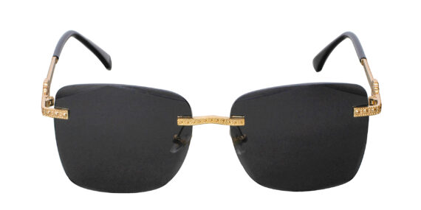
Brand | TOM FORD
Model Name | Estilo FSG
Price | RS 2000
PRODUCT DETAILS

